Current Pump used in canning line

https://www.ifm.com/us/en/product/PI2796?tab=documents

* How capri suns are pouched: (<https://www.capri-sun.com/group/en/how-capri-sun-drinks-are-packed/>)

-pouches are filled at 85 degrees to ensure there are no bacteria or germs present

-pouch is vacuum-sealed immediately

-drink is cooled down to avoid condensation

-straw is pasted on the pouch

-weight is checked

-hourly taste and quality checks (pouches are randomly taken out of production line and tested, then stored so they can retrace complaints)

-capri sun pouching machine: <https://www.alibaba.com/product-detail/capri-sun-machine_1600051377285.html>

-costs $5,500

-weighs 180 kg ~ 400lb

-operates at 220V

* <https://www.northernbrewer.com/collections/brewing-equipment?msclkid=4e5c7ed9400b15dfe6371d8d238dc71a&utm_source=bing&utm_medium=cpc&utm_campaign=(NB)%20Equipment%20-%20General&utm_term=home%20beer%20making%20equipment&utm_content=Equipment%20-%20General>

^ can find a bunch of parts involved in filling cans/bottles with beer (valves, tubes, dispensers, etc)

* Manual and Semi-Auto solutions from pouch manufacturer:

<https://astrapouch-na.com/product-category/fillers/>

-Cost not listed but I believe the Astrofill Easy Start is the semi auto design Mathew mentioned

-Astrofill Probox has automated capping and filling

* Similar design to Probox here: [SRAML Automatic Bag in Box Wine Filling](https://www.youtube.com/watch?v=goKP8MKkxdE)

[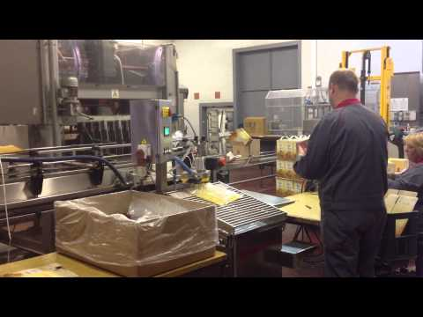](https://www.youtube.com/watch?v=goKP8MKkxdE)

This design has a similar filling/capping mechanism, but I think we should expand further with better depalletization (release latch perhaps). However, this does show that operating the machine can be a one-person job and the whole process only takes two ppl (one labeling and one running the machine) or one person doing all the labeling first then filling.

* Wireless remote controlled 2HP pump cart: <https://www.craftmasterstainless.com/pump-cart-pumps>

Costs $3950, looks like it is a portable beer pump

-key features include:

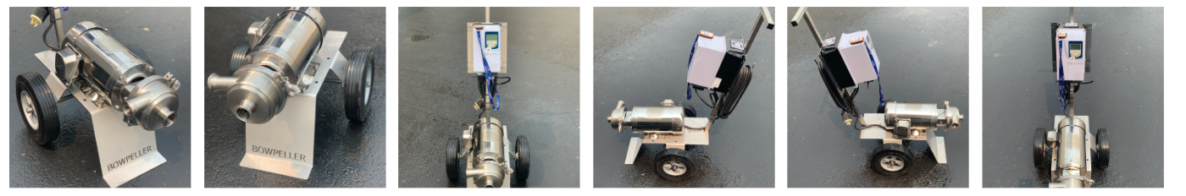

* There’s another option of slightly different pump for $2850

^from <https://www.craftmasterstainless.com/brew-hoses>

* The following website provides different types of automated systems: <https://www.smbsales.com/used/packaging-equipment/fillers-filling-equipment/?msclkid=46da8bfd82df1bf4c3cde8ab8062578c&utm_source=bing&utm_medium=cpc&utm_campaign=Used%20Equipment%20Smart%20Broad-G15159792640&utm_term=automatic%20liquid%20filling%20machines&utm_content=Used%20Filling%20-%20Consolidated>
* Idea similar to what Matthew uses right now: <https://www.youtube.com/watch?v=IFsDVUCC6AY>

Company: “Geissberger Farmhouse Cider”

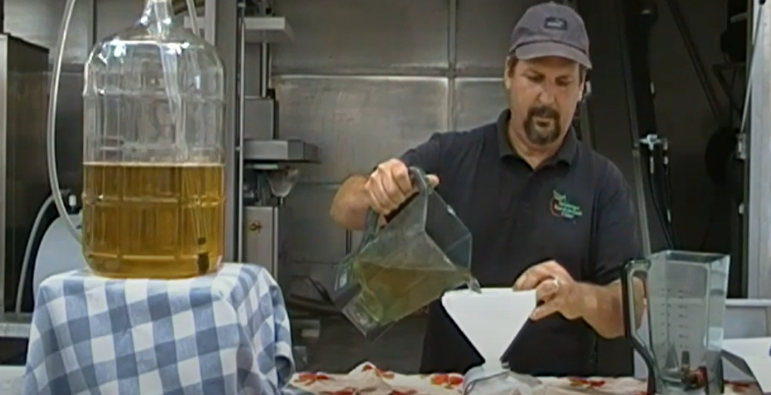 use funnel to put liquid into spout of pouch

* <https://www.youtube.com/watch?v=Ze7eCkavKBo>

watch above video for an existing solution: CDF

-differences: their “pouches” are a continuous piece of plastic, like how garbage bags are attached to the next one in the roll and you have to tear it off along the perforated line

-allows for the continuous feed of the pouches into the machine

CDF corporation: more info here : <https://www.cdf1.com/solutions/bag-in-box/>